Assignment 2
Date Assigned: 09/07/2018
Due: Midnight 09/14/2018 on iLearn
Please read turn-in checklist at the end of this document before you start doing exercises.
Section 1: Pen-and-paper Exercises
- Arrange the following functions in ascending order of growth rate (7 points):
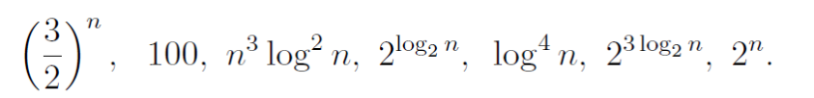
You are NOT required to justify your ordering.
Note:
In this problem, you are asked to identify if f1(n) < f2(n) for a “sufficiently large” input size n. However, for small values of n this is not always true.

Note: Since we did not finish the discussion of comparison, we will work on this problem in Assignment 3.

- Analyze the following code and provide a "Big-O" estimate of its running time in terms of n. Explain your analysis.
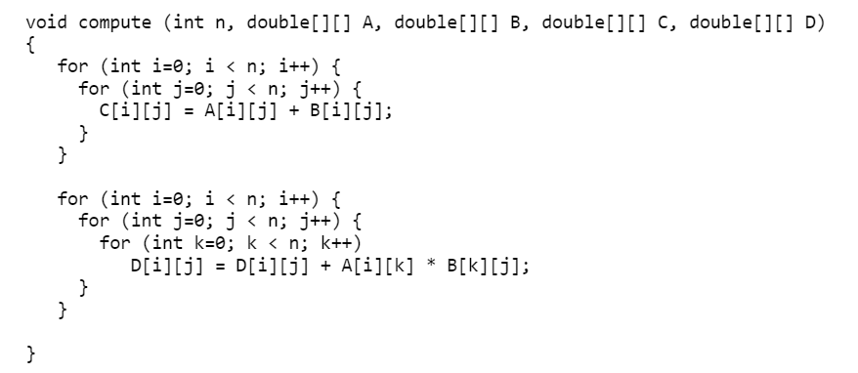
Note: Credit will not be given only for answers - show all your work:
(5 points) steps you took to get your answer.
In order to correctly provide a big-O estimate of the running time in terms of n, I will analyze each line of code using pseudocode:
For i in [0, int n – 1]
For j in [0, n – 1]
i, j in [2d array C] = i, j in [2d array A] + i, j in [2d array B]
End for
End for

For i in [0, n – 1]
For j in [0, n – 1]
For k in [0, n – 1]
i, j in [2d array D] = i, j in [D] + i, k in [A] * k, j in [B]
End for
End for
End for
- The statement within the first two nested for loops contains 2 instructions
- i within the first loop will be iterated n – 1 times, while j will be iterated n – 1 times in the nested loop for each time i is iterated. Both loops will iterate for the value of n – 1, which makes it’s predicted time (n – 1)^2 + 2
- The statement inside the second set of nested for loops contains 3 instructions
- i in the first for loop iterates for the entire value of n – 1, and for each value of i, j will iterate n – 1 times in the second nested loop, while for each value of j, k will iterate n – 1 times in the innermost nested loop.
- This leaves us with a time prediction of (n – 1)^2 + 2 + (n – 1)^3 + 3, which is equivalent to (n – 1)^2 + (n – 1)^3 + 5.
(5 points) your answer.
My solution to the first problem is O((n – 1)^3).
- Analyze the following code and provide a "Big-O" estimate of its running time in terms of n. Explain your analysis.

int j = 1, i = 0;
while (i < n)
{
i = i + j;
j++;
}
Hint: The loop variable ‘i’ is incremented by 1, 2, 3, 4, … until i becomes greater than or equal to n.
Note: Credit will not be given only for answers - show all your work:
(5 points) steps you took to get your answer.
Step 1: Pseudocode:
j = 1, i = 0
while i < n
i = i + j
j++
end while
- The first line of code contains 2 instructions
- i is iterated n / j times throughout the while loop, incremented by j each iteration, j is also incremented each time
- The first line within the while loop contains 2 instructions, while the second line contains 1 instruction
- This leaves me with the prediction 2 + ((n / j) + 3)
(5 points) your answer.
My Big-O solution to the problem is O(n / j)

TURN-IN CHECKLIST:

- Answers to Section 1 (.doc/.txt/.pdf), and to Section 2 (all your source Code (.java files)). Remember to include your name, the date, and the course number in comments near the beginning of your code/report.

- Create a folder and name it 'FirstName_LastName_assignment_1'. In the newly created folder copy and paste your files (.doc/.txt/.java files). Then compress the folder, and push it to iLearn.

